Learning intention: to convert mixed number fractions to improper fractions.
- Convert the mixed numbers to improper fractions and use <, > or = to complete the comparison statements.
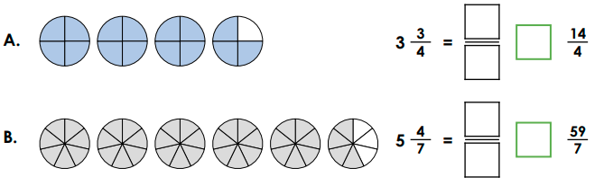

- Identify the missing numbers
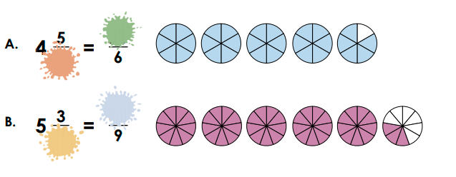

- Raymond says
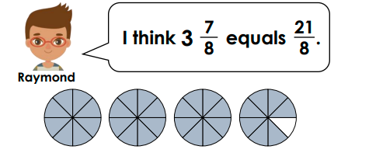
Is he correct? Explain your answer.

