Blue and grey
Read the green and red words for our new story.
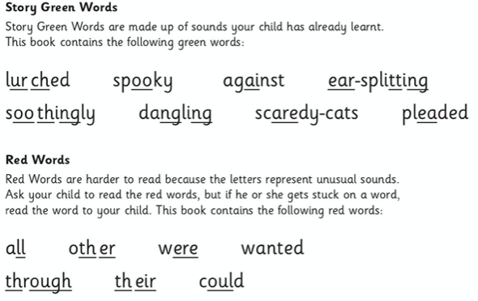
Vocabulary check: these are some new words in the story. Read the definition (the meaning) of each word by yourself or with a grown up. In your head, can you make up a sentence that uses each word? Say your sentences out loud and check they make sense.
