To use adverbials
Look at each of the animals and create sentences for each one using adverbials.
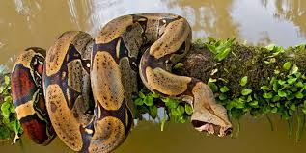
Here is an example using the
A poisonous, sleek snake slithered silently by.
Angrily, he hissed into the ear of the exhausted, sleeping man.
