Maths
- What number is represented below?
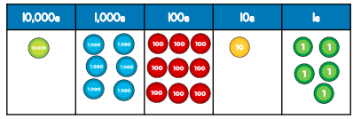
______________

Georgia says that the number is a multiple of five. Is Georgia correct? Explain your reason why.

- Complete the missing numbers:
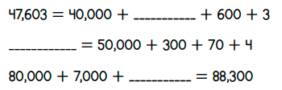

- In a game, people have some playing money to buy houses. Each person starts with the following play money.
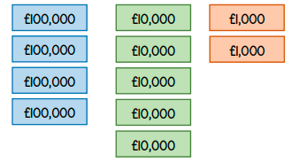
How much does each player start with?

- Circle all the numbers that round to 4,750 to the nearest 10.
4752 748 4748 4745 4755

- What is the missing number?
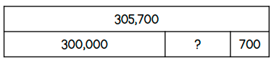

- What numbers are shown by the arrows?
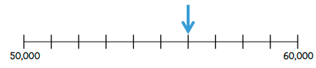

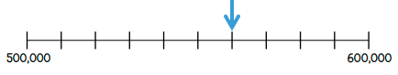

- Complete the following using < , > or =
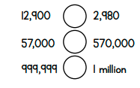
- Arrange the numbers below to make an odd number between 70,000 and 100,000.
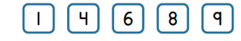
___________________

Round your number to the nearest 100 ___________________
Round your number to the nearest 10,000 _________________

- Complete the missing numbers.
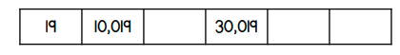

- The thermonmeter shows the temperature in London in May.
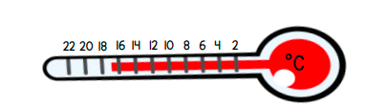
In January the temperature was 20 degrees colder.
What was the temperature in January?

