Learning intention: To understand the ‘x’ and ‘÷’ symbols.
Write the two multiplication calculations for these arrays.
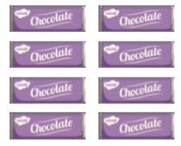

________ x ________ = ________

_______ x _________ = __________

________ x ________ = ________

_______ x _________ = __________
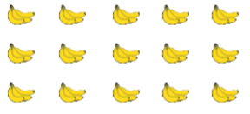

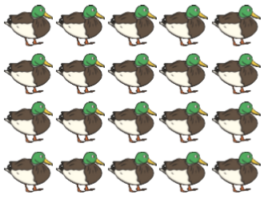

________ x ________ = ________

_______ x _________ = __________
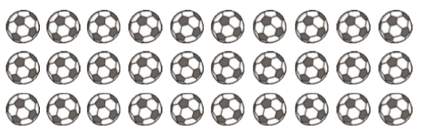

________ x ________ = ________

_______ x _________ = __________

________ x ________ = ________

_______ x _________ = __________

