Alternative Maths Learning intention: to find a half of a quantity.
Find of these amounts:
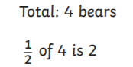
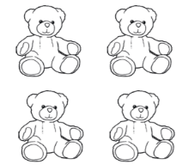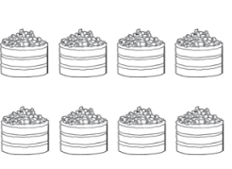
Total number of cakes:_____
of 8 is _____

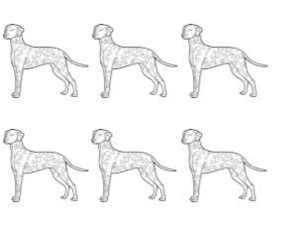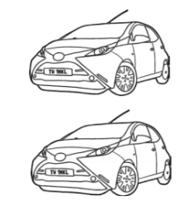
Total number of cars:____
of _____is ____
Total number of dogs: ___
of ___ is ____

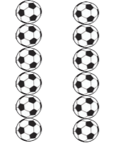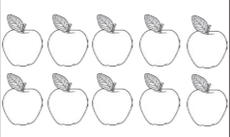
Total number of apples: ____
of ___ is ____
Total number of footballs: ___
of ___ is ____

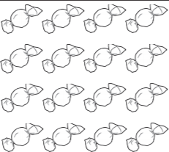
Total number of sweets: ___
of ___ is ____

