Start the day – exercises - Jogging on the spot – start slow then get faster and faster until you cannot go any faster! Then stop and take a breath

https://www.bbc.co.uk/cbeebies/grownups/fun-exercises-to-do-at-home-with-kids there are some nice exercises on this website you could do with your family.
Jo Wicks will also be doing daily exercise. You can find these online by searching for “Jo Wicks daily children’s exercise”. He will be doing a live class on Monday’s, Wednesday’s and Fridays from 9am.
Maths  Today we will be looking at subtraction with one exchange.  Look carefully at the example on the page “To subtract two four digit numbers with one exchange” and complete the questions.  There are also two challenge questions to complete. | Maths – online task  Go to the BBC Bitesize website https://www.bbc.co.uk/bitesize/articles/zrtsy9q.  Complete the quiz starting with subtracting three digit numbers and move onto four digit numbers.  Scroll down the page from the quiz. Then click Guardians: Defenders of Mathematicia. This is a game to learn more and sharpen your skills on this topic of subtraction.
English - We will be looking at words with the “aw” sound but spelt with the “augh” or “au” graphemes.  For each word practice your spelling of them using the look/cover/write/check method we have used before.  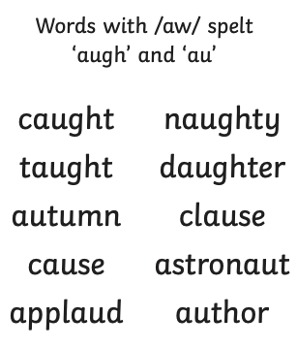  Complete the pages about articles (It has the title Articles and Determiners, Page 12). Read carefully about what at article is then you have 2 tasks to complete. What was the most common article you noticed? Either choose a reading book to look at or you may write your own story piece of text or story. Can you find all the different articles in that? What was the most common you read/wrote?  Challenge - Is it possible to write a sentence without an article? | English  Education city - https://go.educationcity.com/  Log in, click subjects, then English, then Year 4, then activities.  Click “Band Jam”. This is a game all about pronouns, which you looked at last week. You have to select the correct pronouns to make the sentences make sense.  There is also an activity sheet where you can re-write sentences by choosing a suitable pronoun.
History  Using the image of “The Picts” can you look carefully at the image and answer the questions below it.  You could research what a primary and secondary source of evidence is, this will help you answer the third question. | History (The Picts)  Go to this website BBC Bitesize https://www.bbc.co.uk/bitesize/clips/zr2xpv4  You will see a video called “History of the Picts”. This video will tell you what some of the rulers of Britain thought about a group of people called “The Picts”  Can you record some ideas about who these people were, what they were like and what the different rulers of Britain thought about them.
Reading task - Go onto Oxford Owl  https://www.oxfordowl.co.uk/for-home/find-a-book/library-page/  Click on levels then choose your book band (this will be the same as your reading book). Click a book then log in to read it in. Can you identify any words that you do not know and find out their meaning. You could write these down and make a mini dictionary for yourself.  Remember to read your reading book each day. | Remember school website is: www.moorside.newcastle.sch.uk/website/remote_learning  If stuck email Linda.hall@moorside.newcastle.sch.uk

