Pink and purple Wednesday 3.2.21
Last week you learned the ‘igh’ sound. Use this knowledge to identify the real and nonsense words. Tick the real words ( )
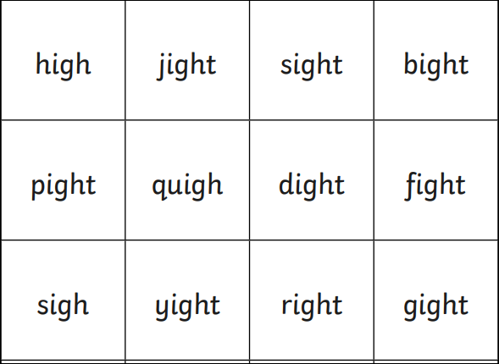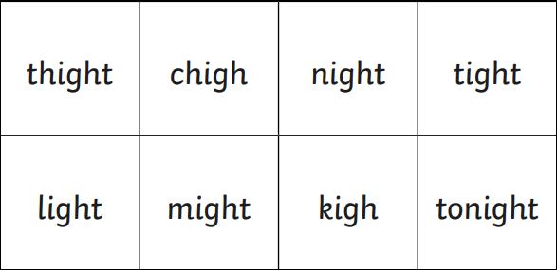

Challenge- spell the real words.

