To understand the Gulf Stream.

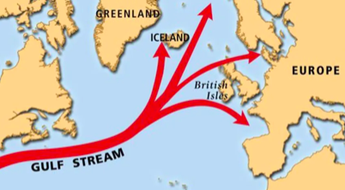

- What is the Gulf Stream?

The Gulf Stream is a large, underwater …………………….. that brings warm water from ………………………., across the ………………………………. .

- Where does the Gulf Stream begin?

The Gulf Stream begins in the ………………………………………. .

- Why is the water warm in the Gulf Stream?

The water in the …………………………….. is warm because the Bay of ……………….. is near the ……………………..

Challenge: Name the 2 places on the map where the Gulf Stream ends

