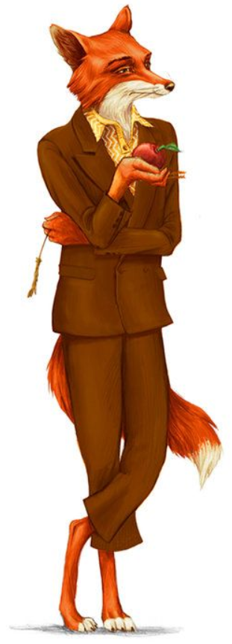
Describing Mr Fox
Look at this picture of Mr Fox

Which of these nouns can be used to describe Mr Fox?

coat fur scales wings ears eyes shoes nose hat tail claws chin

Use some of these adjectives to help you add more detail to the description.

Bushy wild furry red brown blue bright pointy enormous sharp white

For example;
White chin pointy ears
Try to put your adjective and noun into a sentence.
For example;
Mr Fox has a white chin and pointy ears.

