Phonics – th
Can you say the sound, trace it with your finger and then write it?

Say | Trace | Write
th | th | _________________

Can you tick the pictures that have the ‘th’ sound in them?

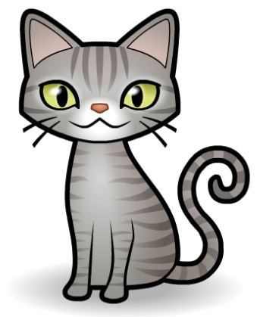

Phonics – th
Can you find the words that have ‘th’ in them?

thin | moth | mad | that
cat | ham | thumb | but
think | mum | tin | with

Can you write what you can see using the ‘th’ sound?

___________________________________________

__________________________________________

Phonics – sh
Can you say the sound, trace it with your finger and then write it?

Say | Trace | Write
sh | sh | _________________

Can you tick the pictures that start with sh?
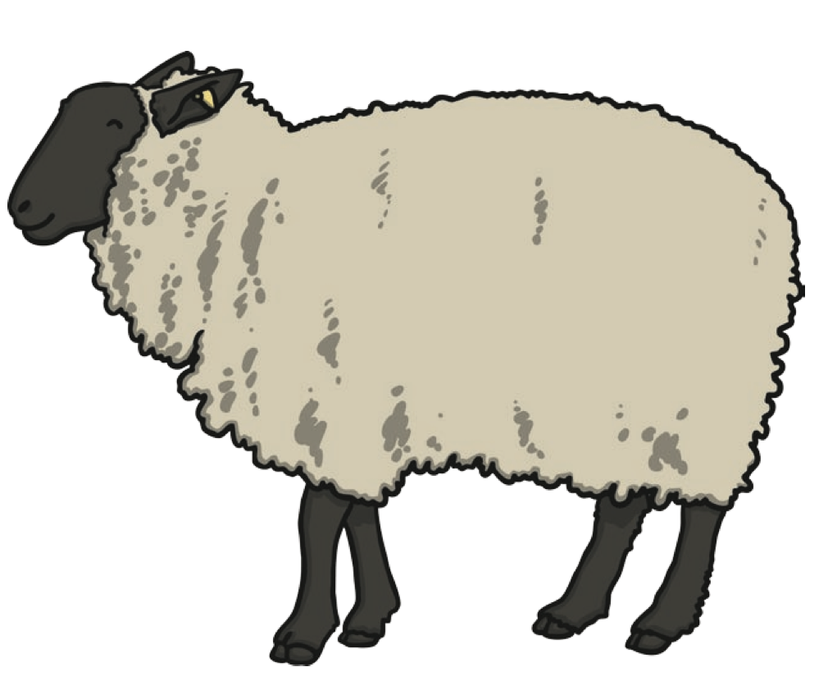 | 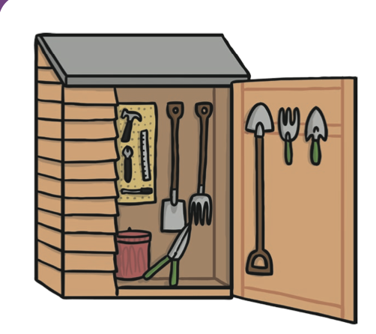
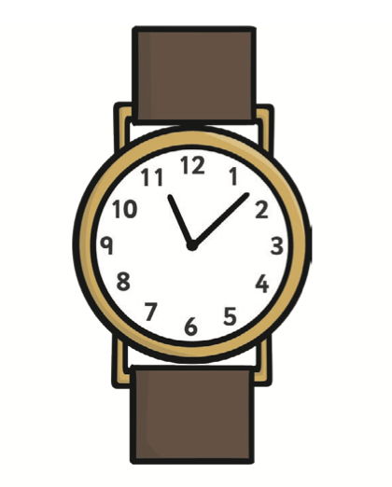 | 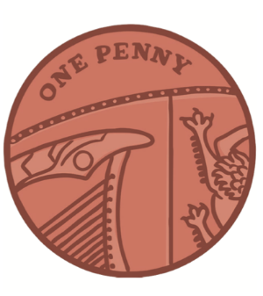 | 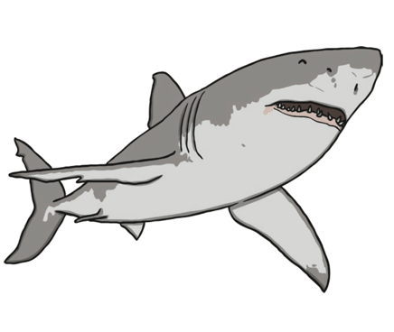

Phonics – sh
Can you find the words that have ‘sh’ in them?

sharp | shed | mad | shop
I | ham | shell | but
shock | shout | tin | you

Can you write what you can see using the ‘sh’ sound?

___________________________________________




