Year 2 (Friday 5.3.21)
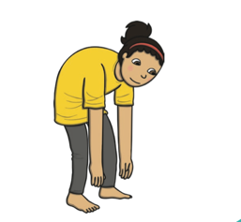
Exercise:
Bend and touch your toes then stretch up high. Repeat this 10 times. Stretch high with your right hand cross it to touch your left foot, do this 20 times. Repeat with left hand to right foot.
English
Learning intention: To write instructions.
Look at the PowerPoint then use your plan to help write your instructions for a new adventure.

Alternative 1: Look at and listen to the PowerPoint. Use the story map and pictures to help write instructions for a new adventure.

Spelling: there their where

Handwriting : Use the PowerPoint- ea
Alternative 1: Use the PowerPoint- oo

Reading
Blue and grey: Find and shade the words to make a sentence to match the picture.
Orange and yellow: Match the pictures to the caption

Alternative reading
Pink and purple: Use your knowledge of ‘ay’ to read these alien words. Identify the real words.
Red and green: Practise reading these words from this week’s book.
Maths
Learning intention: To create a block graph.
Look at and listen to the PowerPoint showng how to create block grpahs and understand the infomration they show. Use your knowledge to complete the worksheet.

Alternative 1: Look at and listen to the PowerPoint about block graphs. Use your knowledge to create a block graph using the information on the worksheet.

History- To learn about famous people in history.
Look at the PowerPoint and find out about what the objects were from last session. Look for clues about why the person was famous.
Explain to an adult or write down notes to show what you have learnt about this famous person so far.
Alternative: Match the description to the word.

Remember school website is:http://www.moorside.newcastle.sch.uk/website
If stuck or want to send completed work then email linda.hall@moorside.newcastle.sch.uk

