To plan my own Aboriginal art design using symbols
Look carefully at these Aboriginal symbols below. Choose three symbols that you will use for your design.

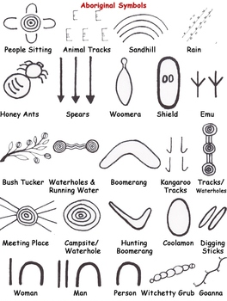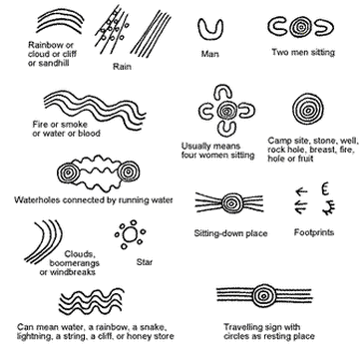
On the back, please plan you own design. These are important points to remember
- Choose three symbols that will use to create your storyline and art work.
- What materials will you use to create your final design
- What material would you choose to make it on
- Plan your repeated pattern.

