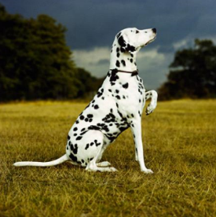
LOST DOG
Spot the dog.
On Sunday night, Jack Smith went for a walk in Green Park with his dog called Spot. Spot is a big dog and he has black and white spots. They heard a loud noise and then Spot ran away.
“I want my dog back,” said Jack.
If you find Spot, you can ring Jack on 01926 3759 or you can take him to a vet.

- When did Jack lose his dog?

- Where did Jack go for a walk?

- What is Jack’s dog called?

- Why did Spot run away?

- If you find Spot what should you do?

