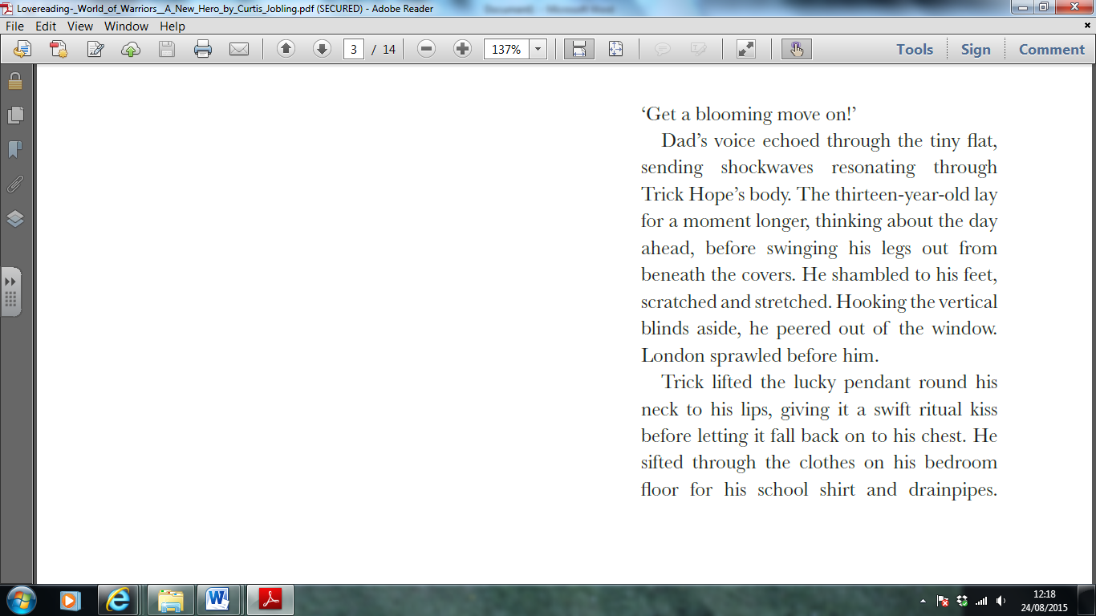English - From ‘World of Warriors – A New Hero’ by Curtis Jobling

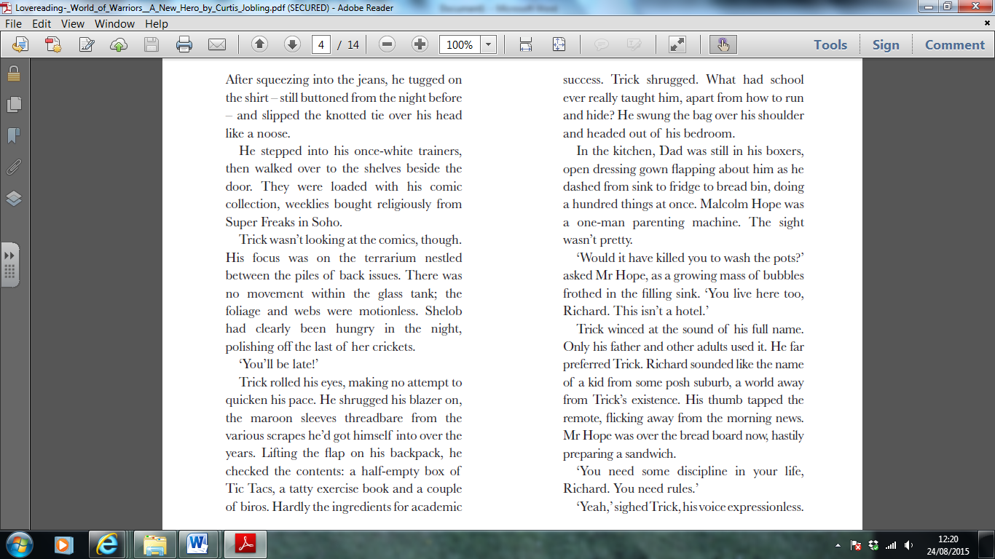

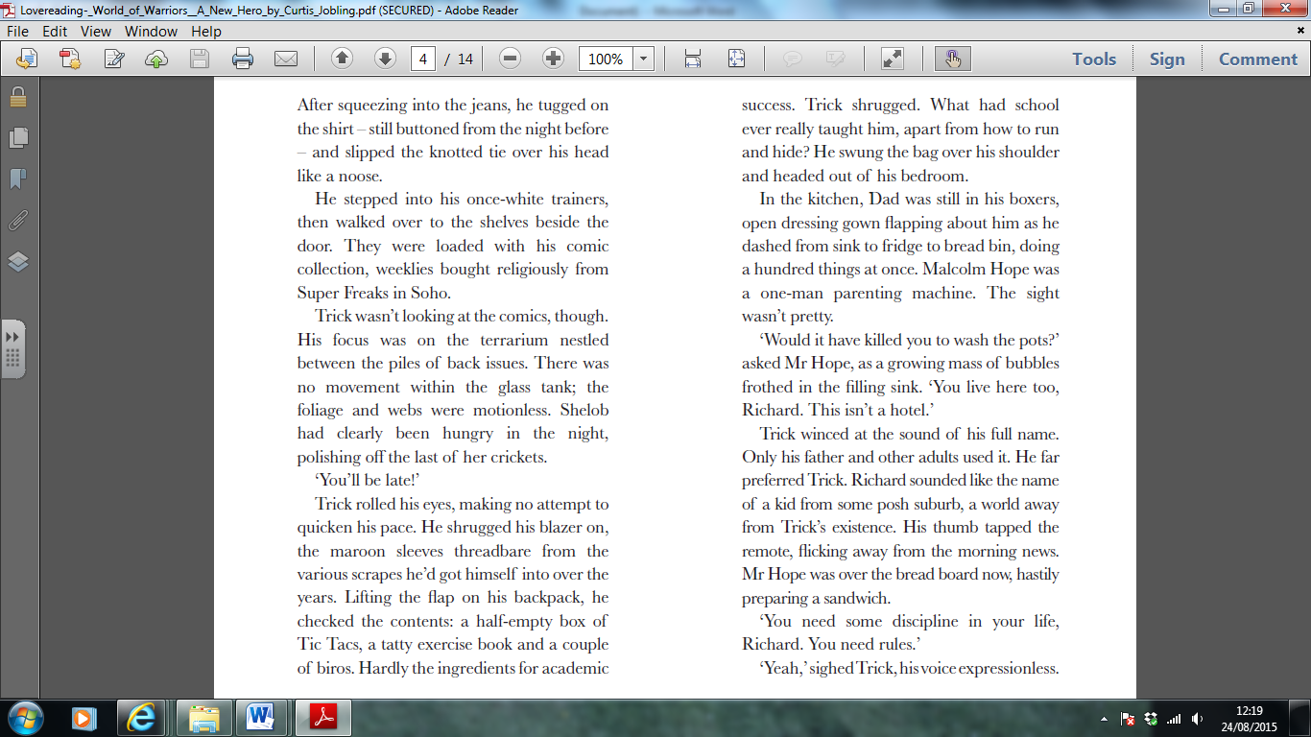

Retrieving Information

1. Find the sentences with the following words in and see if you can clarify the meaning of the following words:
2. resonating
3. ritual
4. pendant
5. Find and copy **one** word that shows that Trick’s blazer is old.
6. Find and copy **one** word that shows that Trick never forgets to buy his magazines.

Making Inferences

1. What type of creature lives in the terrarium and how do you know?
2. Why do you think Trick kisses his necklace?
3. Is Trick’s room tidy? Give 2 pieces of evidence to support your answer.

Writer’s Choices

1. Why has the writer chosen to describe the knotted tie as “like a noose”? What does this tell us?
2. Why has the author selected words like “shrugged” and “shambled” to describe how Trick moves?