Nursery and Playgroup Learning (Week 25/01/2021)

Start of the day – Try these different positions each day this week, count to five each time whilst you stay in the position before the next one. As you get towards the end of the week, see if you can count more than five as you hold the position.

Literacy – Over the next, few days use the PowerPoint and follow the story of Goldilocks and the Three Bears. Try to retell the story by yourself to someone in your family.

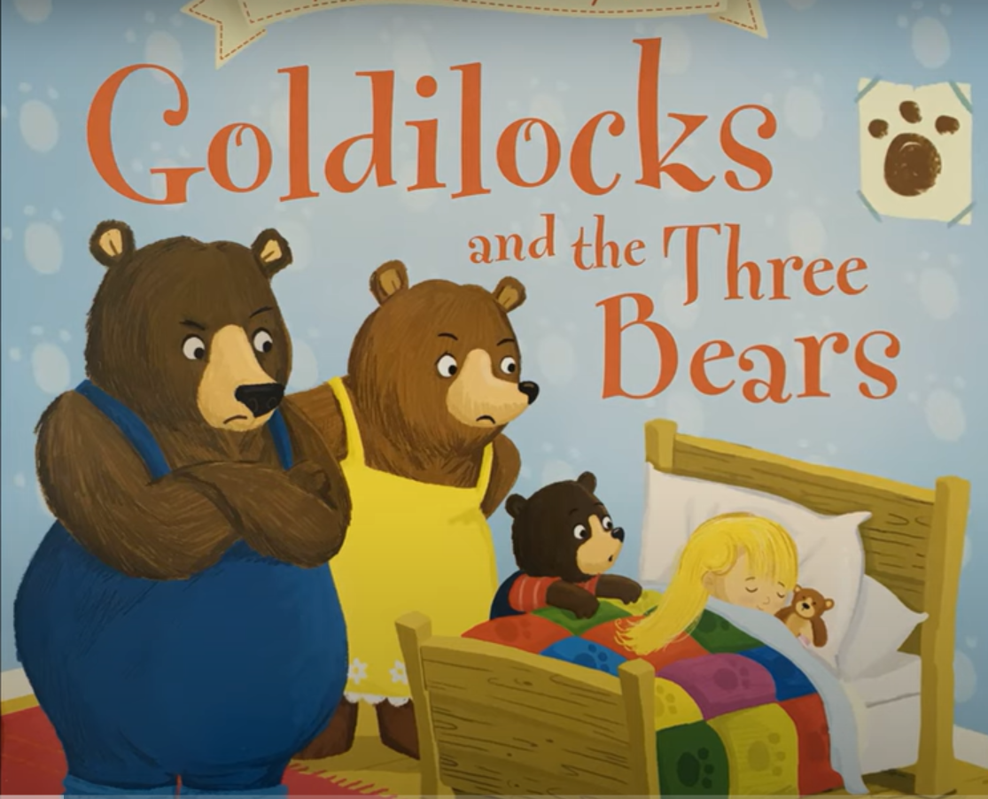
When you have shared the story talk to someone in your family about what happens in the story.
Can you remember the different characters in the story? Can you draw the different sized bears?

Handwriting pattern – Get the bears to their bowls and then to their porridge - before following the handwriting pattern go over it with your finger first then with a pencil.
Maths
- Share the PowerPoint Sizes and explore the different sized objects with someone in your house.
- Count from 0 to 10 in a little voice then in a medium sized voice.
- Look at the picture of Goldilocks to order and put numbers in rectangles to show which object she used first. If you have some colour pencils, you could colour this picture next.
Songs and rhymes to learn:  - Sing and do the actions for Round and Round the Garden – use the PowerPoint to help you with the words.  - Follow the PowerPoint and join in with the different Nursery Rhymes try to sing each of them every day so you begin to learn sing them without any help.  - Try to put some actions into your rhymes as you sing them. | Remember the school website is:  http://www.moorside.newcastle.sch.uk/website  If you are stuck or want to send completed work then email  linda.hall@moorside.newcastle.sch.uk

