Learning intention: To create a block graph.
Use pictures to create the block graph.
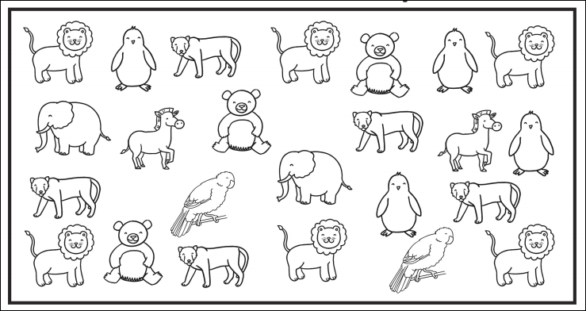
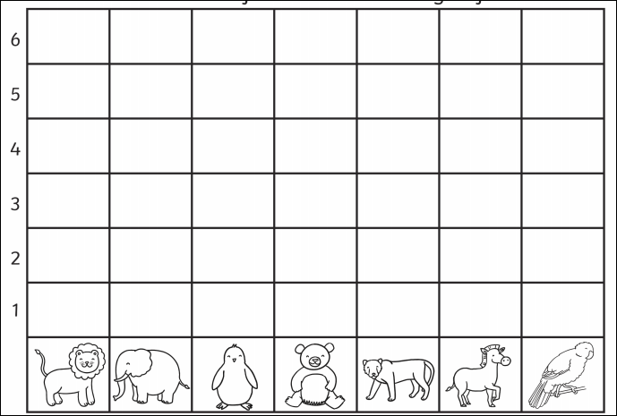
There were ………… elephants.
There were………..birds.
Which animal was there most of?.......................................

Which animal was there less of?.......................................

