Can you follow the lines to the insect then if you have pencils colour them in.

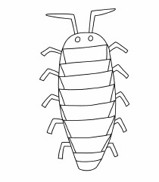C:\Users\Sandra Jepson\Desktop\lines 1.jpgC:\Users\Sandra Jepson\Desktop\lin.jpgC:\Users\Sandra Jepson\Desktop\lines 1.jpgC:\Users\Sandra Jepson\Desktop\nnn.jpg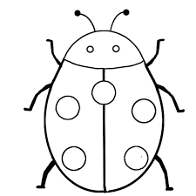C:\Users\Sandra Jepson\Desktop\nnn.jpg