Alternative Maths 2
Learning intention: To identify and describe the properties of 3D shapes, including the number of edges, vertices and faces.

Match the 3D shape to its name
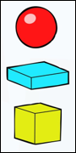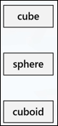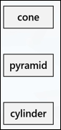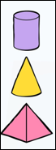

Draw a line to put the shapes under the corrects heading
