Blue and grey
Weather of the world
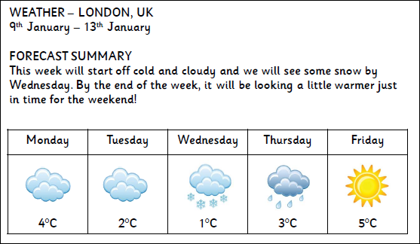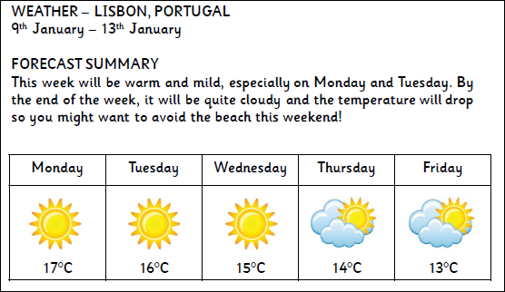
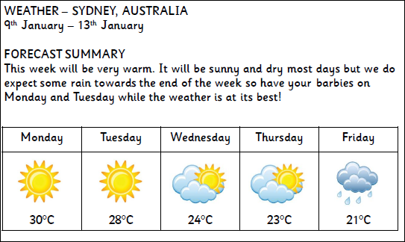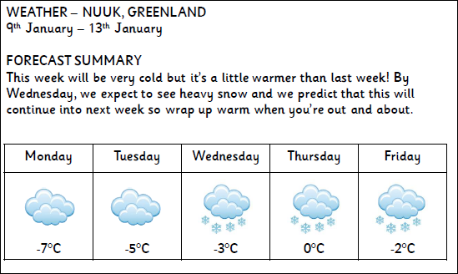

1. How many days will ot snow in London this week?
2. Which city is the coldest this week?
3. Which city is the hottest this week?
4. Will it get hotter or colder through the week in Lisbon?
5.What date is it on Monday?
6. Why might you not want to go to the beach in Lisbon at the weekend?
7.What sort of clothes would you wear on Monday and Tuesday in Sydney this week?
8. What sort of clothes would you wear in Nuuk this week?
9. Which city would you prefer to be in this week? Why?

