Number formation
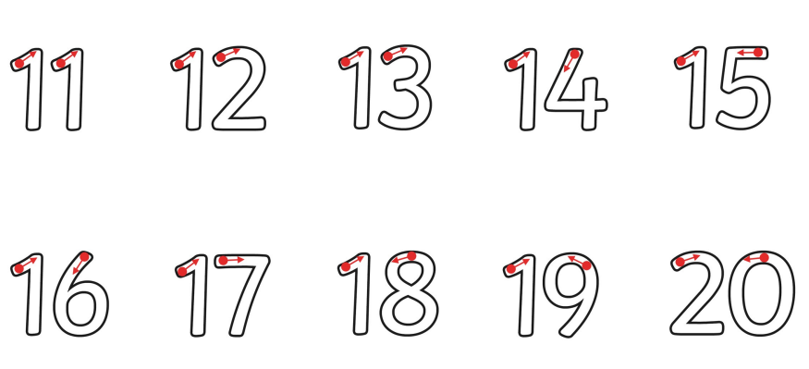
Can you trace the teen numbers and say what they are?

