What is the time shown on each clock
Some have been done to help you.

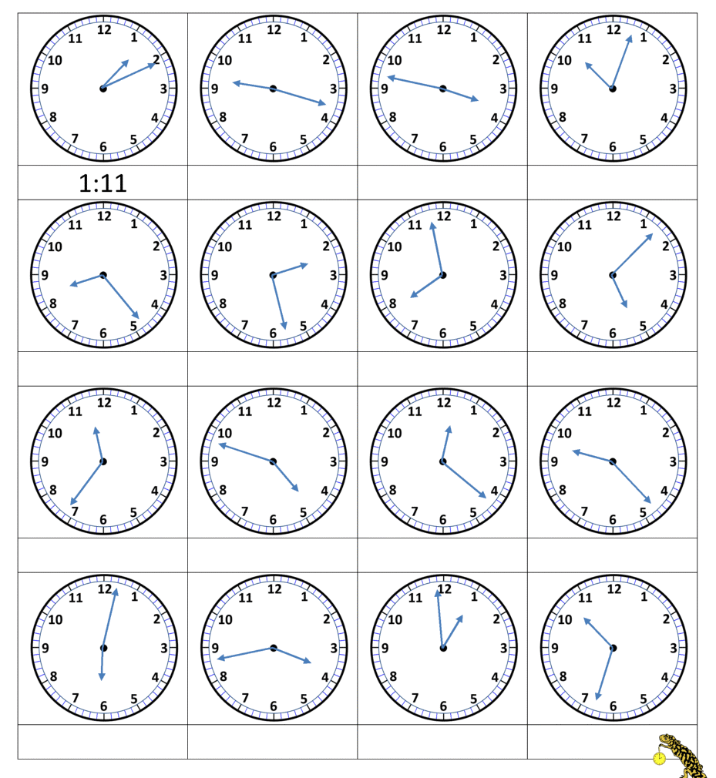
17 minutes past 9 13 minutes to 4

