**Maths: To identify square numbers**

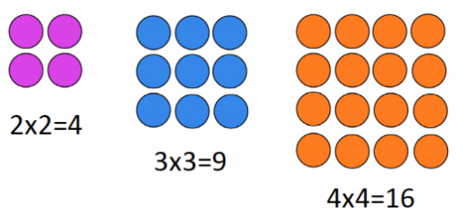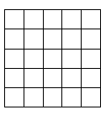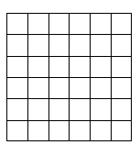

**True or false?**

This array shows $2^{2}.$

**Challenge**

Now can you spot any patterns? How could your times tables help you calculate square numbers?

**True or false?**

This array shows $9^{2}.$

**True or false?**

This array shows $6^{2}.$

**True or false?**

This array shows $8^{2}.$

**True or false?**

This array shows $5^{2}.$