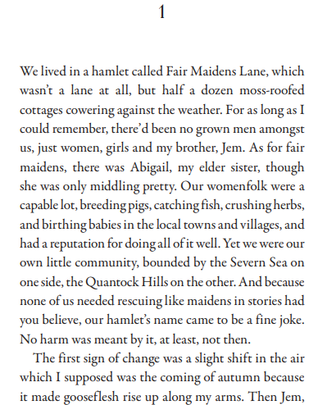
The Somerset tsunami by Emma Carroll

Reading Learning intention: to retrieve and interpret information from a text.
- What does the word “cowering” mean?
- Now you have defined the word, what does it suggest about the weather?
- What is the brother called?
- Find the word that means the same as “average”?
- List two things that the women can do which make them capable.
- What did the narrator think the change was?
- Predict what happens next.

