Learning Intention- to find equivalent fraction
Can you find the equivalent (same) fractions of these shapes?

16
16
16
16
16
16
1
2
1
2
14
14
14
14
12
12
1 is the same as __ 1 is the same as _
2 4 2 6

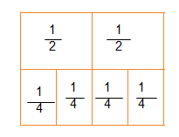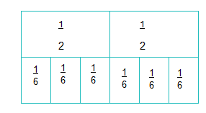
2 is the same as __ 2 is the same as ___
2 4 2 6

Can you find the equivalent fractions from this shape?

