Maths Alternative 1
- Max is counting in tens from zero, which numbers will Max say?

- Emma is using a place value counters to represent a number.
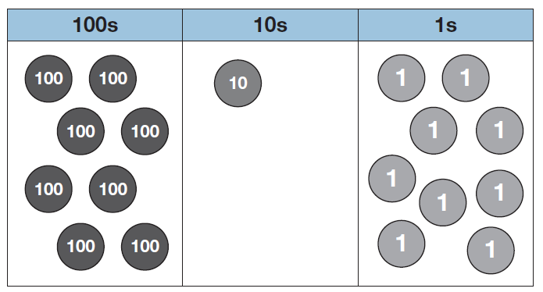
Write Emma’s number in words. ____________

Emma adds this counter to her number What is Emma’s new number? ___________

- Complete the part whole models.
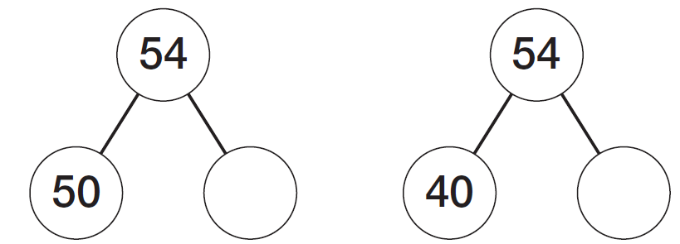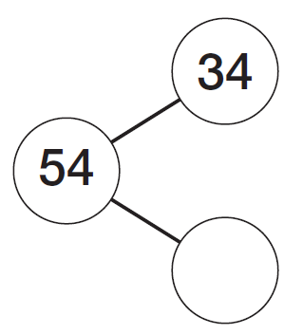

- Complete the missing values
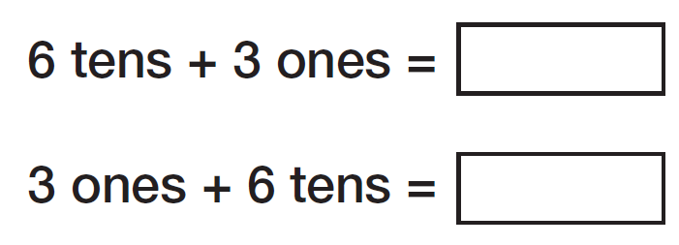

- Some counters are placed over numbers on a number track.
What number is under A? ______
Find the difference between D and C. _________

- There are 100 children at a school fair. 57 of the children are boys. The rest are girls. How many girls are there?

- Apples come in bags of 4 or 5. Tim has 50 apples altogether. He has five bags of 4 apples. How many bags of 5 apples does he have?

- Use the numbers to complete the sentence.

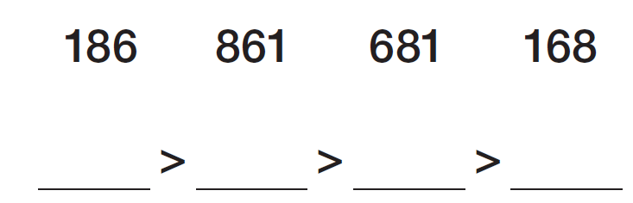

- Sophie reads 416 pages of her book. She reads 127 pages more than Mo.
How many pages does Mo read?

- Complete the missing numbers.

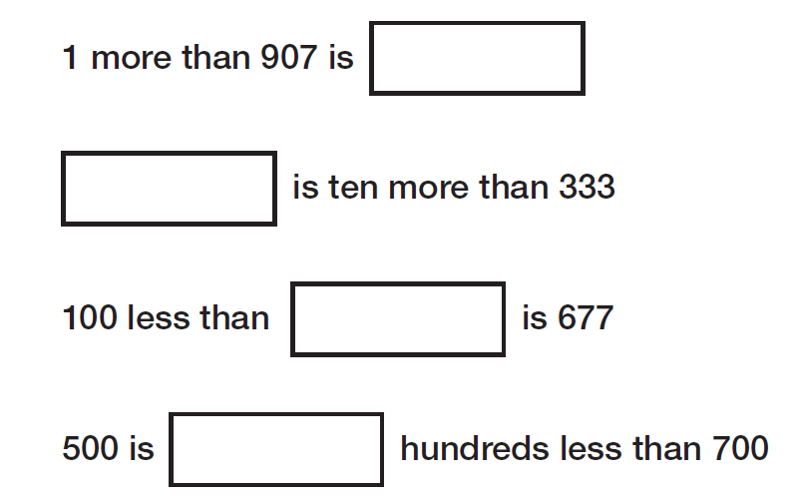

- Fill in the boxes to make the subtraction correct.
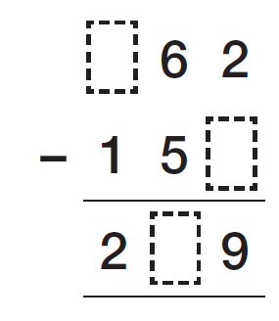

- Work out the missing value
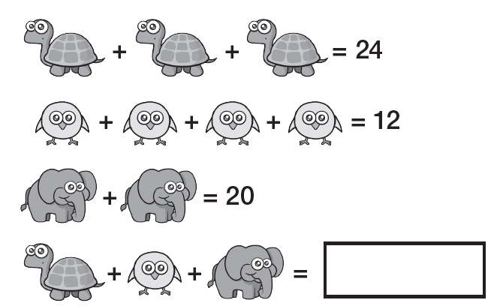

- Beth makes a number.
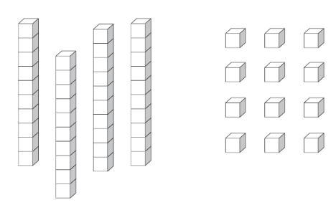
Beth thinks she has made 412. Do you agree? Explain why.

- Here is a number track.
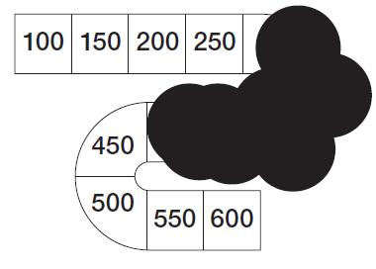
Ian has split paint over part of the track. List all of the numbers covered by the paint.

