29.1.21 English

Use the PowerPoint to recap co-ordinating conjunctions: and or but

Extend the sentences below by choosing a conjunction and adding a second clause.

For example:
The children were very hungry and they began to eat the sweet gingerbread roof.

The wicked witch pretended to be kind _______________________________________
__________________________________________________________

Hansel was trapped in the cage __________________________________________
__________________________________________________________

The evil witch started to put her head inside the oven ________________________________
__________________________________________________________

Gretel asked her brother if they should take the gold ________________________________
__________________________________________________________

Challenge task:

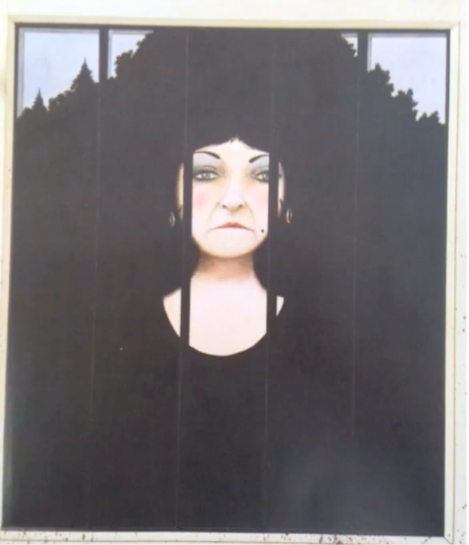
If you finish extending the sentences with conjunctions you could try to write one sentence to describe the character of the stepmother. Remember you need two clauses joined with a conjunction!

