Maths Alternative 2
Number bonds to 20
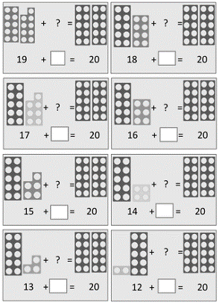
Use this number line to help you.

