Finding one half and one quarter of amounts
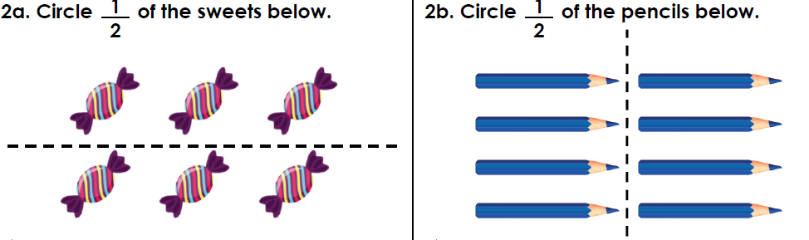
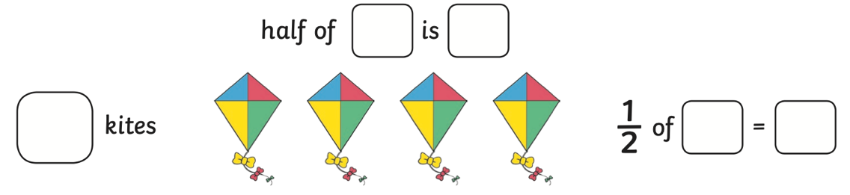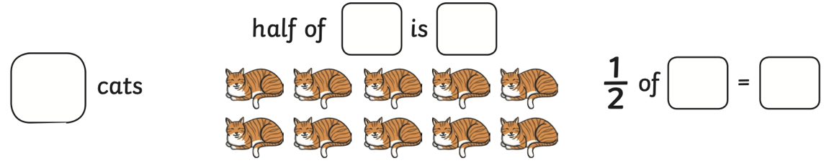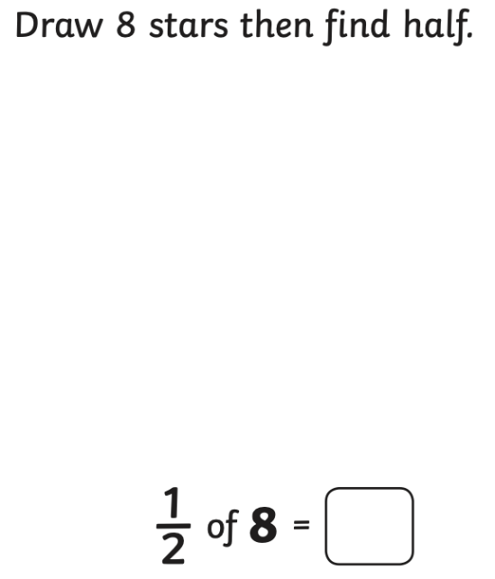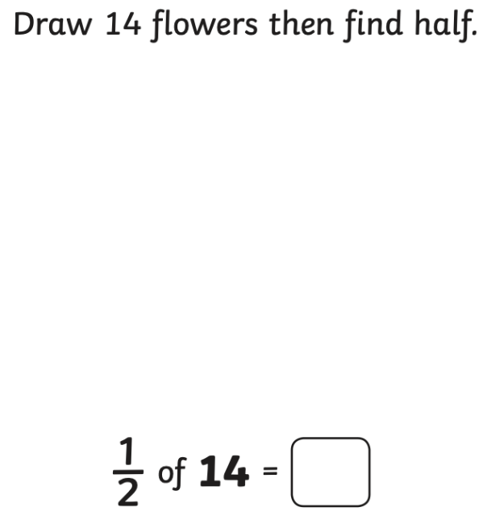
Find
$\frac{1}{2}$ of 10=

$\frac{1}{2}$ of 14=

$\frac{1}{2}$ of 18=

