Year 1 Learning (12.02.21) Alternative
Motor skills  - Have a go at the Leap Frog pencil control sheet.  - Can you do 5 press ups?  - Can you do 5 sit ups? |  | 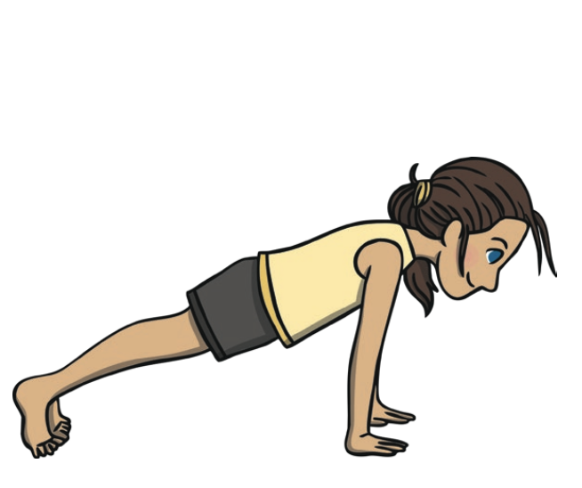 | 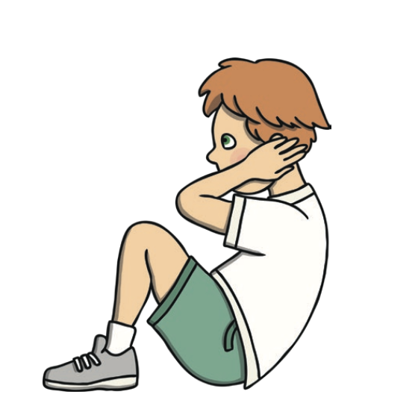
English
Learning intention: To recap ‘Peter and the Wolf’
- Go through the PowerPoint and see if you can use the clues to work out who the characters are and talk about what happens next in the story.
- Phonics: or
- Handwriting: or

English Alternative 1
- Go through the PowerPoint and see if you can use the clues to work out who the characters are and talk about what happens next in the story.
- Phonics: sh
- Handwriting: p

Maths
Learning intention: To recap money
- Go through the PowerPoint and guess the different coins from the clues.

Alternative maths 1
- Go through the PowerPoint and guess the different coins from the clues.

Alternative maths 2
- Go through the PowerPoint and guess the different coins from the clues.

Foundation - Science
Learning intention: To talk about the results of the rain experiment

Go through the PowerPoint to find out about what happened in our experiment. Tell your family, a teddy or say out loud what happened and why.

Can you think of an idea of how to do an experiment about how much snow there has been?

Reading:  Read the common exception words sheet.  Alternative Reading 1:  Read the common exception words sheet.  Alternative Reading 2: | Remember, the school website is:  http://www.moorside.newcastle.sch.uk/website  If you are stuck or want to send completed work then email:  linda.hall@moorside.newcastle.sch.uk

