Maths: To describe a position

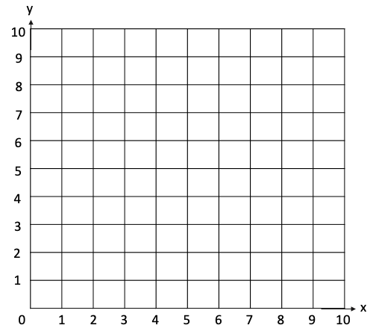
- Fill in the co-ordinates for each colour dot

( , ) ( , ) ( , ) ( , ) ( , )

