Identify line types
A line that runs from left to right across the page is called a ____________________ line.

A line that runs straight up and down the page is called a _____________________ line.

Horizontal or vertical?
Label the lines with either horizontal or vertical.

Perpendicular and parallel

Lines that never meet are called _________________ lines.

Straight lines that meet at a right angle are called ______________ lines.

Draw a line that is parallel to each of the lines below. Remember parallel lines never meet. I have done one for you.

1. 2. 3. 4. 5.

Now draw a line that is perpendicular to each of the lines below. Remember, perpendicular lines meet at a right angle. I have done one for you.

1. 2. 3. 4. 5.

Now complete these reasoning questions using your understanding of parallel and perpendicular lines.
1. 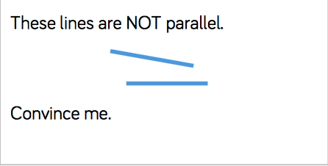 2. 