To understand the Gulf Stream.

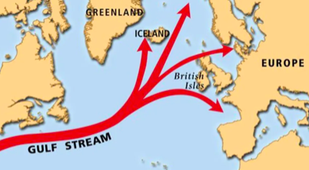

- What is the Gulf Stream?

The Gulf Stream is a large, underwater c………………….. that brings warm water from M………….. across the A………………O…………. .

- Where does the Gulf Stream begin?

The Gulf Stream begins in M …………………… .

- Why is the water warm in the Gulf Stream?

The water in the Gulf Stream is warm because the Bay of M…………….. is near the E…………………..
Word Bank

Mexico Equator Atlantic current

Mexico Ocean Mexico

