Learning intention: To understand the ‘x’ and ‘÷’ symbols.

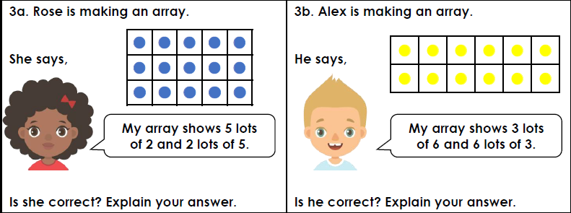

Toby says that his array shows 5 ÷4 = 20. Is he correct? Explain your answer.
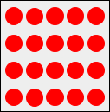

Sam says that his array shows 20 ÷ 5 = 4. Is he correct? Explain your answer.
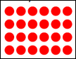

Milo Says that his array shows 21 ÷3 = 7. Is he correct? Explain your answer

