Pictures of regions of Europe.
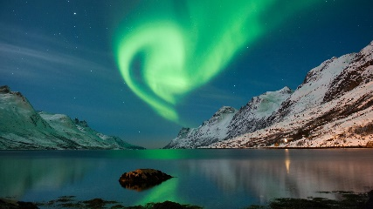 | 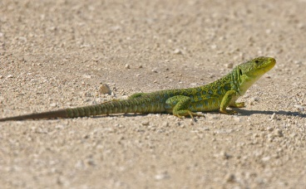 | 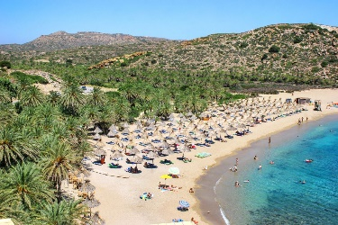
- Aurora Borealis (_______ lights) | - Lizard | - Island of Crete, with palm trees
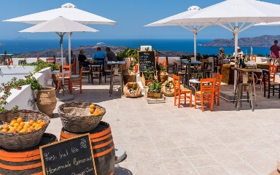 | 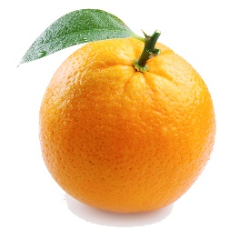 | 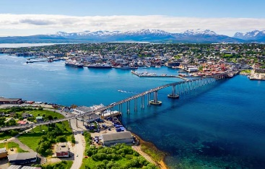
- Eating outside | - Orange | - Tromso, in the Arctic Circle
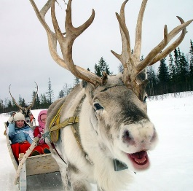 | 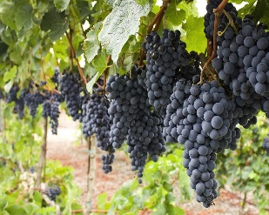 | 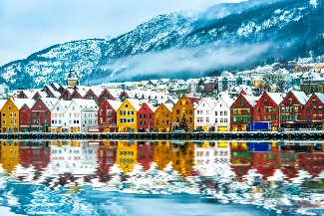
- Reindeer | - Grapes | - Bergen on the North Sea Coast
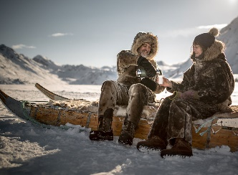 | 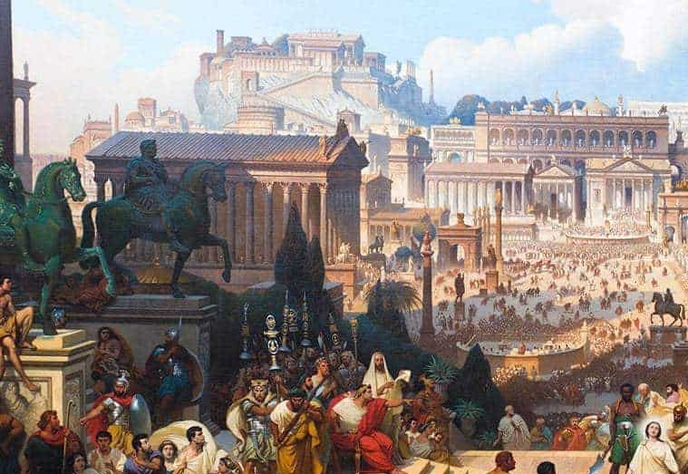 | 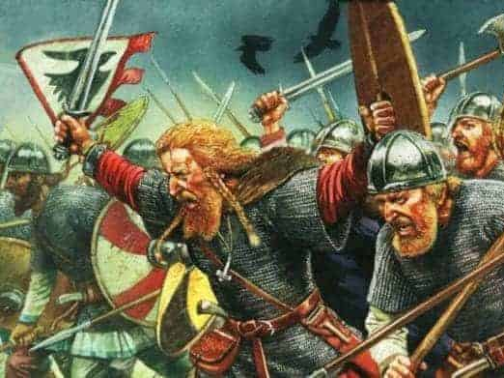
- Inuit people sitting on a sledge | - Ancient Rome | - Viking Raiders

These pictures show different aspects of Northern and Southern Europe. There are six images of each. Which do you think are Northern European and which do you think are Southern European pictures?
Things to think about.
- Weather and climate – hot or cold, wet or dry
- Where do plants grow? Think about the fruit!
- History-
- Habitat – where an animal lives, what it needs to survive.
- Clothing – suitable clothing for the weather.
Northern Region | Southern Region
6.
Put the picture numbers in the correct place.

