The Maya’s
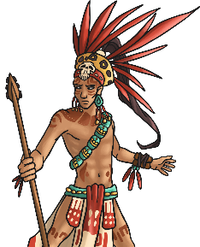
The ancient Maya people were quite a sophisticated bunch! They developed a writing and number system; studied and charted the stars and planets; invented three complex calendars to keep track of time; built impressive temples, palaces, monuments and cities; skilfully farmed the land and established a complex political system.
The ancient Maya were a clever, deeply religious people who valued intelligence and learning. This helps to explain how and why they were able to develop a complex, thriving civilisation which began over 2000 years ago.
The Ancient Maya Place in Time
The Maya civilisation came into being around 2000 BC and cities such as El Mirador became large and powerful from 300 BC onwards.
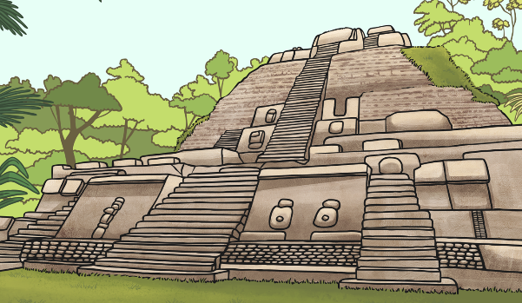
By around AD 900, cities in the rainforest were abandoned and people moved up north to the highlands of Guatemala and the Yucatan. This was because there was an extensive drought in the area that lasted a long time and people needed to move out of the rainforest. Cities like Chichen Itza were still thriving in AD 1000 and the Maya civilisation was still in existence in AD 1500. It was due to the arrival of the Spanish in the 16th century that their ancient cities fell to ruin.

Mesoamerica
‘Mesoamerica refers to an area where a number of societies had been formed before the Spanish arrived in the 16th century. It covers Mexico and the northern parts of Central America. ‘Mesoamerica’ can also refer to the culture of the people who lived there. The Maya lived in the south east of this area.
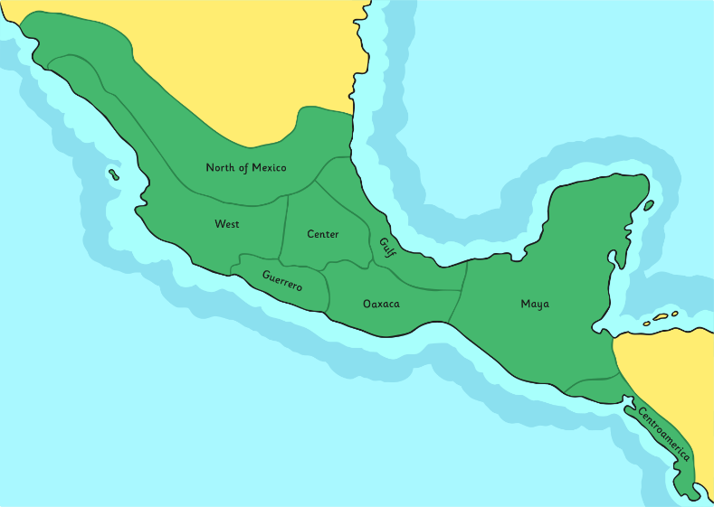
Today, the area the Maya used to live in spreads over 5 countries: Mexico (southern Mexico and the Yucatan Peninsula), Belize, Guatemala, a small area of west Honduras and the very north of El Salvador.
Some of these ancient Maya cities were almost 1000km apart yet they shared the same culture and way of life.

