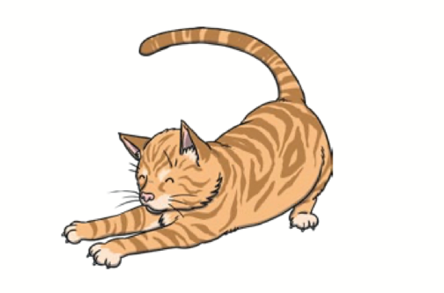
Poem 1 - Jim

Jim is a cat.
Jim has a hat.
Jim is on a mat.
Jim is not a rat!

Poem 2 – A bug

I can see a bug,

It is in the jug!

I can see a bug,

It is on the rug!

I can see a bug,

Don’t touch the plug!

