Purple and pink Monday 8.2.21
Read the text again and answer these questions.
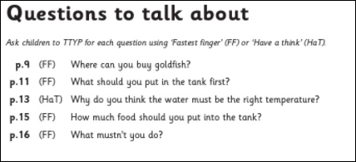

Find and write down the imperative verb (bossy word) from each instruction.
P10- why do you think you need to buy a clear tank?
P11- what is gravel?
P13- What other word could be used instead of ‘add’?
P15- What do you notice about the fish food?
P16- Do you think you should left the fish out of the water to stroke it? Explain your answer.

