22.1.21

To evaluate art work
Have a look at the art work below. Could you select one that you would like to evaluate?
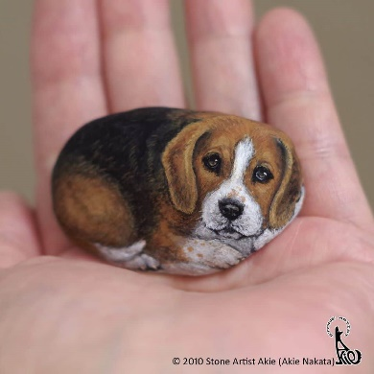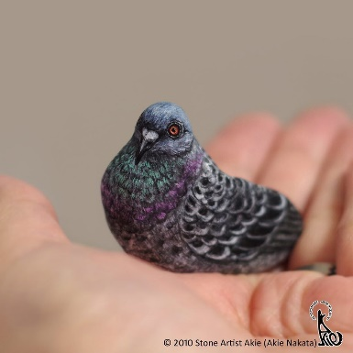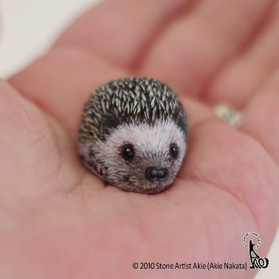

What has the stone been created into?

How do you think Akie Nakita achieved this? Can you see the individual brush marks? What colours have been used?

What do you like about the art work?

Would you change anything about the art work?

Here are some key words to help.

Paint stone brush carefully small colours dog pigeon hedgehog

Here is an outline of a stone.
Now, could you think about what you could create on it? Use your imagination and sketching skills to sketch a chosen animal , just like Akie Nakata.

