English

LO: To understand sentence structure

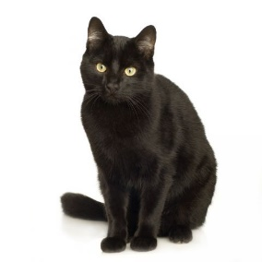

|  |  |  |  |
| --- | --- | --- | --- |
| cat | black. | The | is |

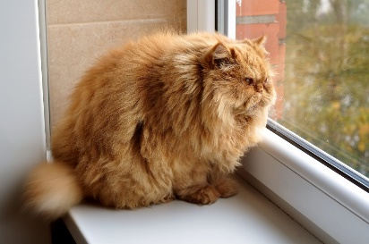

|  |  |  |  |
| --- | --- | --- | --- |
| fat. | is | cat | The |

|  |  |  |  |
| --- | --- | --- | --- |
| likes | This | fish. | cat |

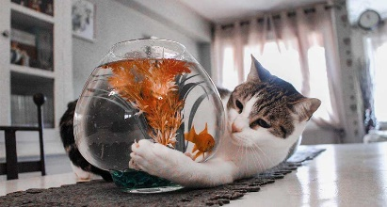



|  |  |  |  |
| --- | --- | --- | --- |
| This | cat | milk. | drinks |



|  |  |  |  |  |
| --- | --- | --- | --- | --- |
| asleep. | cat | The | is | big |

|  |  |  |  |  |  |
| --- | --- | --- | --- | --- | --- |
| the | on | mat. | The | sat | cat |

