Nursery and Playgroup Learning
(Week 22/02/2021)

Start or end of the day – This week we are going to look at some simple yoga moves. Yoga is a way to exercise our bodies, our breath, and our minds all at the same time. So when we try out these exercises we need to try and breathe in through our noses and out through our mouths slowly and carefully whilst we try to stay in position with the exercise for a few seconds. Try these different positions each day this week, count to five each time whilst you stay in the position before the next one. As you get towards the end of the week, see if you can count more than five as you hold the position. Remember to do your breathing each time. You have two sets of exercises try one and then the other the next day then over the week change which ones you do.

Literacy
Our story this week is Rosie’s Walk. Use the PowerPoint and follow the story about Rosie the hen and her walk. With someone in your family try to guess what happens before you read the next slide of the story. Once you are familiar with the story use the story map to retell the story in the correct order to someone in your family or a friend.
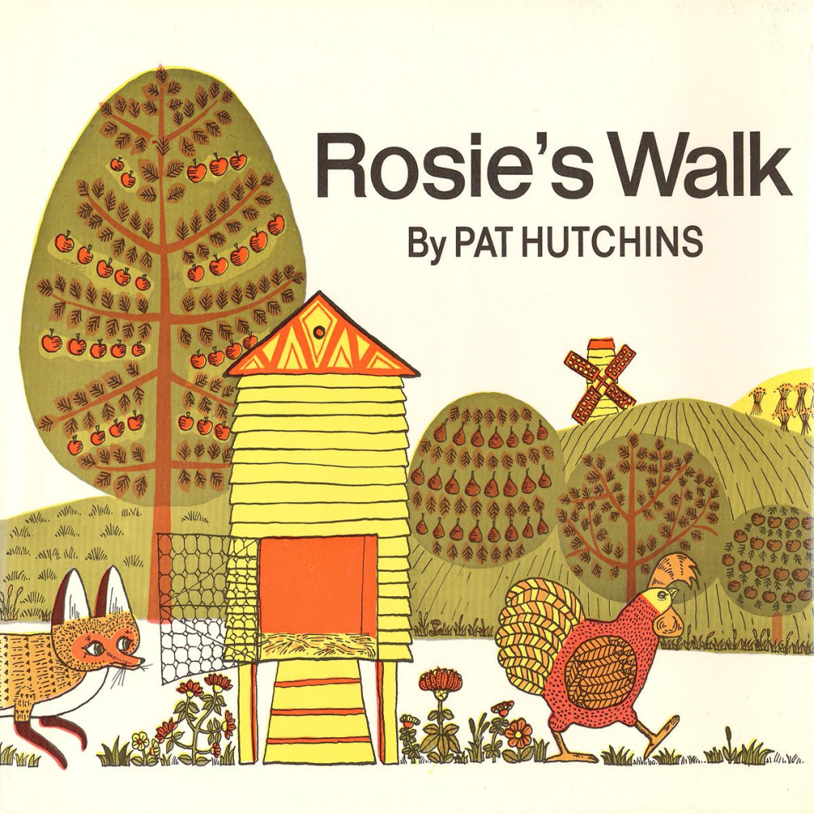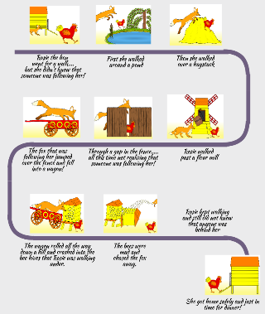
Story map
Maths
Staying with our story of ‘Rosie’s Walk we are going to look the story again though this time we are going to focus on the mathematical language in this story. This language focuses on positional language. Use the PowerPoint and follow the story with someone in your family about Rosie the hen and her walk. Try to work out what will happen next. Take part in the activity at the end of the PowerPoint.

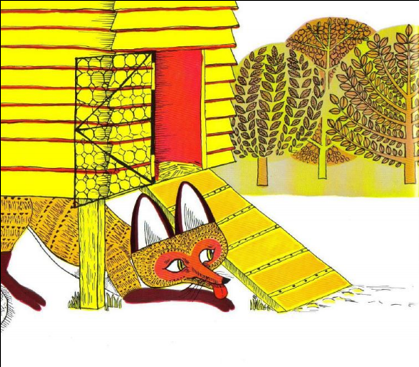

- Now let us count from zero to ten using our fingers to help us.
- Follow the PowerPoint for number 3 and build on your counting skills.
- With your finger and with the help of someone in your family go over the numbers 6 to 10 before doing this with a pen or pencil.
Understanding the World
We are going to explore what you might see in the woods. Before sharing the PowerPoint talk to someone in your family about what you think you might see if you went into the woods. Think about what you might see if were to dig in the soil or if you were to lift up a stone. Share and explore the PowerPoint then talk to someone in your family to see if you were right. Can you recall the different creatures from the PowerPoint?
Handwriting
Follow the lines to the different insects, try this with your fingers first before using a pen or pencil.

Sharing a story
Use the PowerPoint with someone in your family and share the story called The Haircut. Once you have shared the story chat with someone in your family about what happens in the story.

Songs and rhymes to learn:  - Use our nursery rhyme PowerPoint to sing the rhymes we know and try to put some actions into your rhymes as you sing them. | Remember the school website is:  http://www.moorside.newcastle.sch.uk/website  If you are stuck or want to send completed work then email  linda.hall@moorside.newcastle.sch.uk

