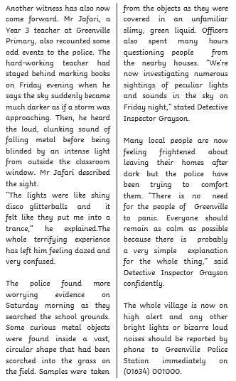
English
Alternative 1
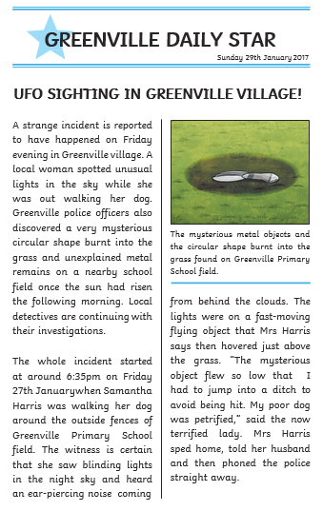

- How can you tell this is a newspaper report?

- When did the incident happen?

- Where did the incident happen?

- Name two weird things which happened in Greenville:
      - …………………………………………………………………………

      - ……………………………………………………………………………

- What was Samantha Harris doing when she saw the bright lights?

- Why do you think the author used the word ear-piercing to describe the noise?

- What is Mr Jafari’s job?

- What colour was the mysterious liquid?

- Why do you think the detective was confident?

- Who should you call if you see or hear anything strange?

