Maths Learning Intention: Telling the time
Write the time underneath each clock using o’clock, half past, quarter to or quarter past.
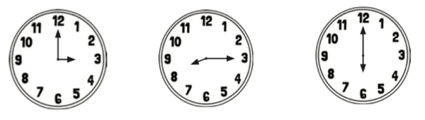

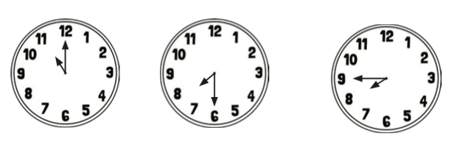

Now draw the hands on the clock to match the time.
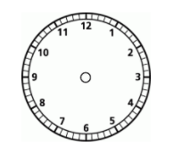
quarter to 5 half past 2 quarter past 10

