Alternative Maths Learning intention- to convert improper fractions into mixed number fraction
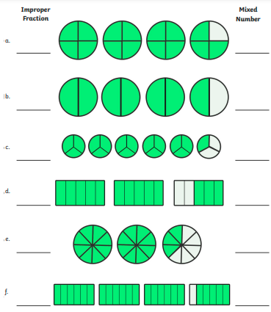
Mixed number fractions
Improper fractions

