Start of the day – exercises - Run on the stop for one minute - Feel your heart beat – what do you notice?

Ten star jumps (counting backwards) twenty touching toes and fifteen jumps on the spot.



**Maths –** Complete the addition work below

Then link into BBC bitesize- <https://www.bbc.co.uk/bitesize/articles/z3gnm39> - Complete addition and subtraction work

For further maths challenge link onto and log on to – TTRockstars <https://play.ttrockstars.com/auth>

**English –** work in CGP book on Verbs - English Autumn Term 5. Then explore how to identify verbs though this link - <https://www.bbc.co.uk/bitesize/articles/zfc2mfr>

Also, look at using verbs through this link - <https://www.bbc.co.uk/bitesize/articles/z3y9vwx>

**Science -** Create a poster, which explains what a force is and use some key vocabulary such as:

**Push pull twist speed move direction balanced unbalanced**

Before you begin use forces link to help you - <https://www.bbc.co.uk/bitesize/clips/zch4wxs> and explore the following link:<https://www.bbc.co.uk/bitesize/topics/zvpp34j/articles/zywcrdm>

**Reading**

Link into PowerPoint – Exploring the Deep - follow this story and instructions.

Alternative reading task - PowerPoint – How to make a Peach - follow this story and instructions.

Remember school website is:

<http://www.moorside.newcastle.sch.uk/website>

If stuck or want to send completed work then email [Linda.hall@moorside.newcastle.sch.uk](mailto:Linda.hall@moorside.newcastle.sch.uk)

Maths – Addition

1. Complete these addition calculations.

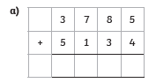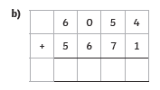 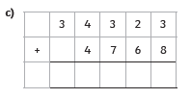

 

Task two.





1. What two children have a combined score of exactly 62, 188?
2. Which two children have a combined score of 65, 944