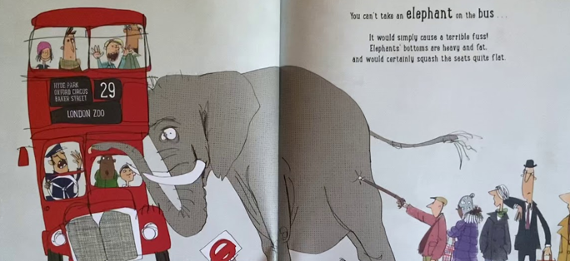
English – Inference
How is everyone feeling? Can you draw or label the emotion that the character is feeling?
Talk to your grown up and tell them why.

