Alternative Maths 1 Learning intentions: to convert improper fractions into mixed number fractions.
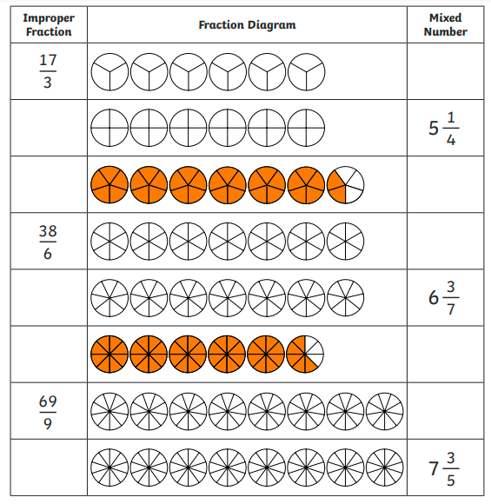
Mixed Number
Diagrams
Improper fractions

