Geography Learning Intention – To analyse how population is distributed across the world.
Look at the pie chart of the world population percentages in 2017. There are currently almost 8 billion people living on Earth in total.
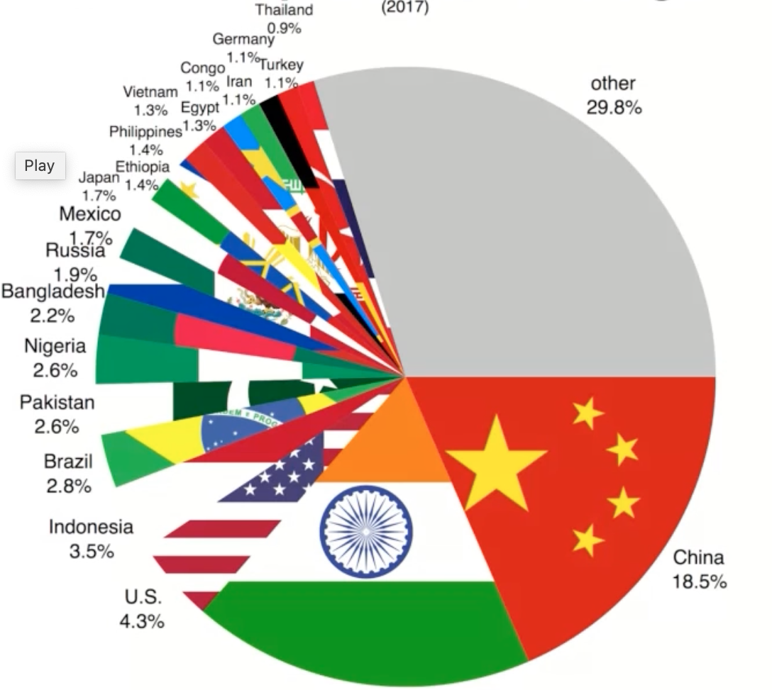

- True or False.
China is the country with the largest population.

- True or false.
The United Kingdom has no population.

- True or false.
The smallest population is Thailand.

- True or false.
The United Kingdom is under the ‘other’ section of this pie chart.

