Learning intention: To solve multiplication problems.
Sam has 10 cards in each set. How many does he have altogether? Write the calculation.
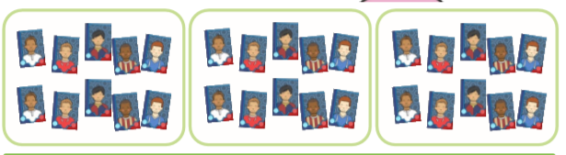

There are 10 doughnuts in a box. How many altogether?
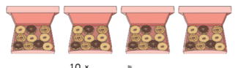
There are 10 candles on each cake. How many altogether?

Challenge.

