Year 1 Learning (10.02.21)
Motor skills  - Wall push: Find a wall. How many arm pushes can you do in 1 minute (60 seconds)?  - Downward facing dog: Start on your hands and knees (breathe in), breathe out and push onto your toes so you look like an upside down v like the picture. Breathe in and out. Slowly go back to your hands and knees on the floor. |  |  | 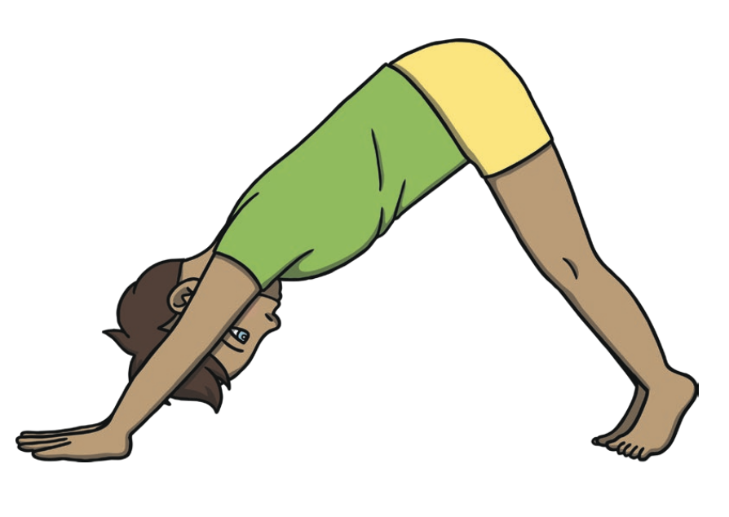
English
Learning intention: To retell a traditional tale.
- Go through the PowerPoint and look at the different story maps and how they have changed with three new characters like yours!
- On the worksheet, make your new story map
- Phonics: oo 2
- Handwriting: oo 2

Alternative English:
- Go through the PowerPoint and look at the different story maps and how they have changed with two new characters like yours!
- On the worksheet, make your new story map
- Phonics: l
- Handwriting: i

Alternative English 2:
- Go through the PowerPoint and look at the different story maps and how they it has changed with one new character like yours!
- On the worksheet, make your new story map
- Phonics: l
- Handwriting: i

Maths
Learning intention: To recap shapes.
Go through the PowerPoint and see if you can answer the 10 questions to guess the different shapes.

Alternative 1:
Go through the PowerPoint and see if you can answer the 6 questions to guess the different shapes.

Alternative 2:
Go through the PowerPoint and see if you can answer the 6 questions to guess the different shapes.

Foundation - PSHE
Learning intention: To find out how to keep safe on the Metro.

Go through the PowerPoint and listen to what is going to be happening on the Metro lines.

Can you design a poster showing people how to stay safe on the Metro?

Reading:  Read the Set 2 Speed Sounds in and out of order.  Alternative Reading 1:  Read the Set 1 Speed Sounds in and out of order.  Alternative Reading 2:  Read the Set 1 Speed Sounds sheet (2) in and out of order. | Remember, the school website is:  http://www.moorside.newcastle.sch.uk/website  If you are stuck or want to send completed work then email:  linda.hall@moorside.newcastle.sch.uk

